Name: Akash Arjun Sawant
Student ID: AF05009971
Batch code: ANP-D1396

Day 3 Lab

Assignment 1. Create a Webpage using an HTML table that shows products and their price. Write the table heading with bold text.

Code:

<!DOCTYPE html>
<html lang="en">
<head>
<meta charset="UTF-8" />
<meta name="viewport" content="width=device-width, initial-scale=1.0" />
<title>Online Items and Prices</title>

<style>
body {
font-family: Arial, sans-serif;
background-color: #f9f9f9;
text-align: center;
margin-top: 60px;
}
h1 {
color: #333;
}
table {
width: 50%;
margin: 20px auto;
border-collapse: collapse;
box-shadow: 0 0 10px rgba(0, 0, 0, 0.1);
}
th,
td {
border: 1px solid #ddd;
padding: 12px;
text-align: left;
}
th {
background-color: #007bff;
color: white;
font-weight: bold;
}
td {
background-color: #fff;
}
</style>
</head>
<body>
<h1>Sample Online Items and Prices</h1>

<table>
<tr>
<th>Item</th>
<th>Price</th>
</tr>
<tr>
<td>Laptop</td>
<td>$800</td>
</tr>
<tr>
<td>Smartphone</td>
<td>$400</td>
</tr>
<tr>
<td>Headphones</td>
<td>$50</td>
</tr>
<tr>
<td>Tablet</td>
<td>$300</td>
</tr>
</table>
</body>
</html>

Output:

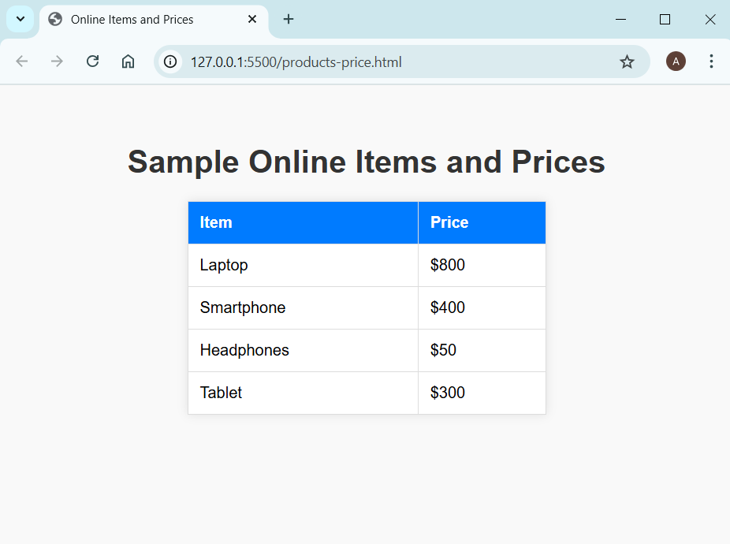

Assignment 2. Create a Webpage using an HTML form that shows various products and their price. The forms should take quantity as input. Add a button called “Calculate Total Price”. There is no need to perform any operation on clicking the button.

Code:

<!DOCTYPE html>
<html lang="en">
<head>
<meta charset="UTF-8" />
<meta name="viewport" content="width=device-width, initial-scale=1.0" />
<title>Online Items and Prices</title>

<style>
body {
font-family: Arial, sans-serif;
background-color: #f4f4f9;
text-align: center;
margin: 0;
padding: 0;
}
h1 {
background-color: #333;
color: white;
padding: 15px;
margin: 0;
}
form {
background-color: white;
width: 50%;
margin: 30px auto;
padding: 20px;
border-radius: 10px;
box-shadow: 0 0 10px rgba(0, 0, 0, 0.1);
text-align: left;
}
label {
display: block;
margin-top: 15px;
font-weight: bold;
color: #4b0082;
}
input[type="number"] {
width: 100%;
padding: 8px;
margin-top: 5px;
border: 1px solid #ccc;
border-radius: 5px;
}
button {
margin-top: 20px;
width: 100%;
padding: 10px;
background-color: #007bff;
color: white;
border: none;
border-radius: 5px;
font-size: 16px;
cursor: pointer;
}
button:hover {
background-color: #0056b3;
}
p {
font-size: 18px;
font-weight: bold;
}
</style>
</head>
<body>
<h1>Sample Online Items and Prices</h1>

<form>
<label for="laptop">Laptop ($800 each):</label>
<input type="number" id="laptop" name="laptop" value="0" />

<label for="smartphone">Smartphone ($400 each):</label>
<input type="number" id="smartphone" name="smartphone" value="0" />

<label for="headphones">Headphones ($50 each):</label>
<input type="number" id="headphones" name="headphones" value="0" />

<label for="tablet">Tablet ($300 each):</label>
<input type="number" id="tablet" name="tablet" value="0" />

<button type="button">Calculate Total Price</button>
</form>

<p>Total Price: $0</p>
</body>
</html>

Output:

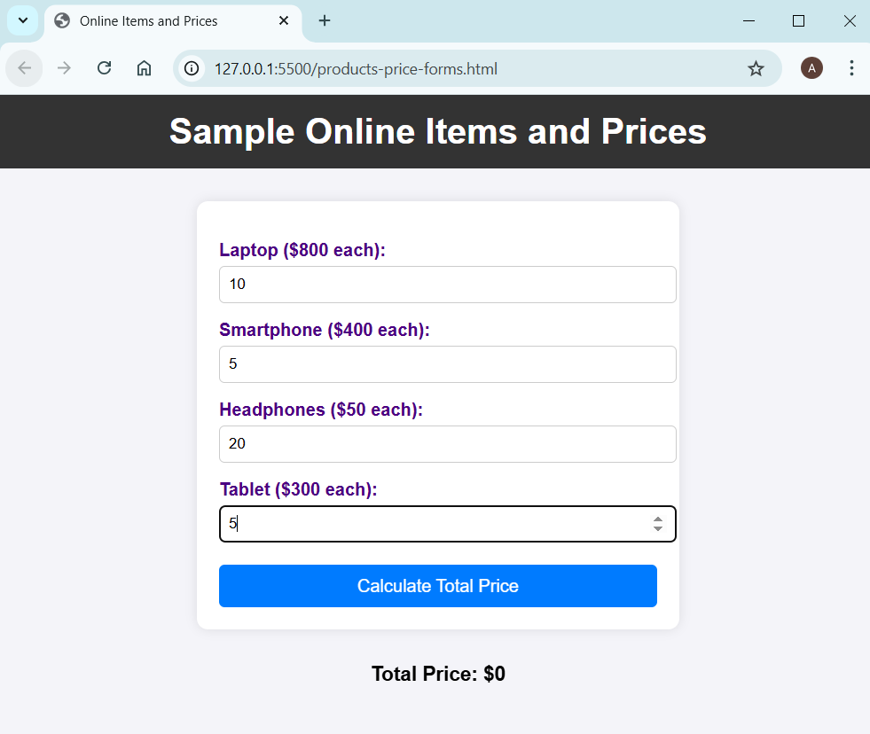

Assignment 3. Create a Webpage using an HTML that will allow users to select a musical album from the list. Use tables, images and styles to decorate the page.

Code:

<!DOCTYPE html>
<html lang="en">
<head>
<meta charset="UTF-8" />
<meta name="viewport" content="width=device-width, initial-scale=1.0" />
<title>Album Selection</title>
<style>
body {
font-family: Arial, Helvetica, sans-serif;
background-color: #f9f9f9;
margin: 0;
padding: 0;
}

header {
background-color: #2196f3;
color: white;
text-align: center;
padding: 20px;
border-radius: 10px 10px 0 0;
}

h1 {
margin-bottom: 10px;
}

h2 {
text-align: center;
color: white;
background-color: #1976d2;
margin: 0;
padding: 10px;
}

h3 {
text-align: center;
color: #333;
}

table {
width: 90%;
margin: 20px auto;
border-spacing: 20px;
}

td {
background-color: white;
box-shadow: 0 0 10px rgba(0, 0, 0, 0.1);
text-align: center;
border-radius: 10px;
padding: 15px;
}

img {
width: 250px;
height: 200px;
border-radius: 8px;
}

footer {
text-align: center;
background-color: #2196f3;
color: white;
padding: 10px;
border-radius: 0 0 10px 10px;
font-size: 14px;
}
</style>
</head>
<body>
<header>
<h1>Album Selection</h1>
<h3>Choose Your Musical Journey</h3>
</header>

<h2>Indian Music</h2>
<table>
<tr>
<td>
<img src="images/indian-melodies.jpg" alt="Indian Melodies" />
<p><strong>Album Title:</strong> Indian Melodies</p>
</td>
<td>
<img src="images/raga-reflections.jpg" alt="Raga Reflections" />
<p><strong>Album Title:</strong> Raga Reflections</p>
</td>
</tr>
</table>

<h2>Western Music</h2>
<table>
<tr>
<td>
<img src="images/symphony-serenade.jpg" alt="Symphony Serenade" />
<p><strong>Album Title:</strong> Symphony Serenade</p>
</td>
<td>
<img src="images/jazz-jamboree.jpg" alt="Jazz Jamboree" />
<p><strong>Album Title:</strong> Jazz Jamboree</p>
</td>
</tr>
</table>

<footer>© 2023 Maharaja Music Company. All rights reserved.</footer>
</body>
</html>

Output:

